**Spencer Gifts Connection Information**

An AD account has been provisioned for you.  The account is:

•         sgicorp\SGajjelli

The password will be sent to you via email.

**Connection information for our VPN:**

Please download and install the Cisco AnyConnect client if you do not have it already.

Once installed, please add the following URL to the AnyConnect client interface (Case Sensitive): vpn01.spencergifts.com/vendor

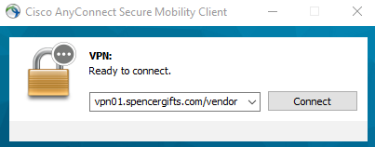

When prompted please use your AD account credentials to log in.

You should be able to grab this installation from my dropbox link below:

<https://www.dropbox.com/sh/thlwvbto6a1skgg/AABMYjUkpOtcI7yzKL3Cdl5xa?dl=0>